TUTORIAL-7
BOUNDARY VALUE ANALYSIS (BVA) & EQUIVALENCE PARTITIONING (EP)
Date: ___________________

Aim
To design and execute test cases using Boundary Value Analysis (BVA) and Equivalence Partitioning (EP) techniques for validating the Age field on a Selenium-based web form.

Problem Statement
To perform black-box testing of the Age field using the validation requirement: Age must be between 18 and 60. Prepare test cases, execute each case, record actual results, and determine Pass/Fail status.

Tools Used
Sr. No. | Tool | Purpose
1 | Selenium WebDriver | Automated execution of test cases on the web form
2 | Selenium Web Form | Application/web page under test
3 | Google Sheets | Recording BVA and EP test cases
4 | Google Chrome | Browser used for testing

Implementation Details
Parameter | Details
Application | Selenium Web Form
Field Under Test | Age
Validation Rule | Age must be between 18 and 60
Testing Type | Manual / Selenium-assisted testing
Test Technique | Black Box Testing – BVA & EP
Browser / OS | Google Chrome / Windows

1. Boundary Value Analysis (BVA)
Boundary Value Analysis focuses on values just below, at, and just above the valid range limits. For the allowed age range of 18–60, the boundary test values are 17, 18, 19, 59, 60, and 61.
Test Case ID | Input (Age) | Expected Result
BVA01 | 17 | Invalid
BVA02 | 18 | Valid
BVA03 | 19 | Valid
BVA04 | 59 | Valid
BVA05 | 60 | Valid
BVA06 | 61 | Invalid

BVA01 – Input Age: 17
Execution: Enter age value “17” in the Age field and submit the form.
Expected Result: Invalid
Actual Result: Invalid
Pass/Fail: Pass
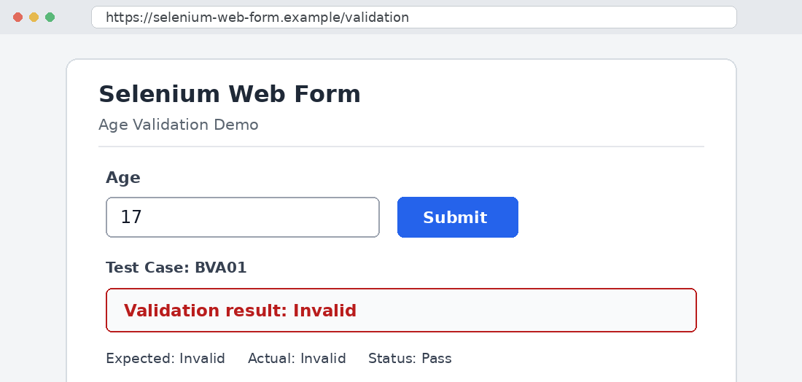

BVA02 – Input Age: 18
Execution: Enter age value “18” in the Age field and submit the form.
Expected Result: Valid
Actual Result: Valid
Pass/Fail: Pass
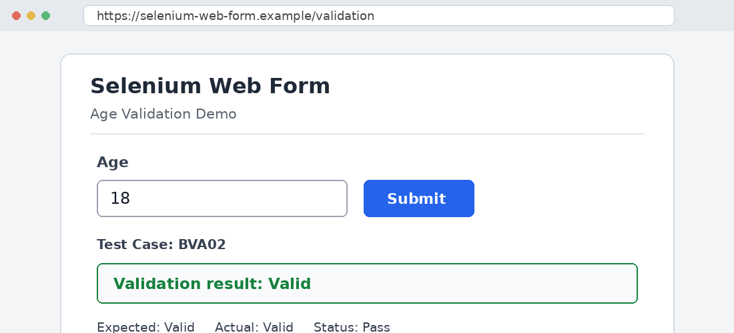

BVA03 – Input Age: 19
Execution: Enter age value “19” in the Age field and submit the form.
Expected Result: Valid
Actual Result: Valid
Pass/Fail: Pass
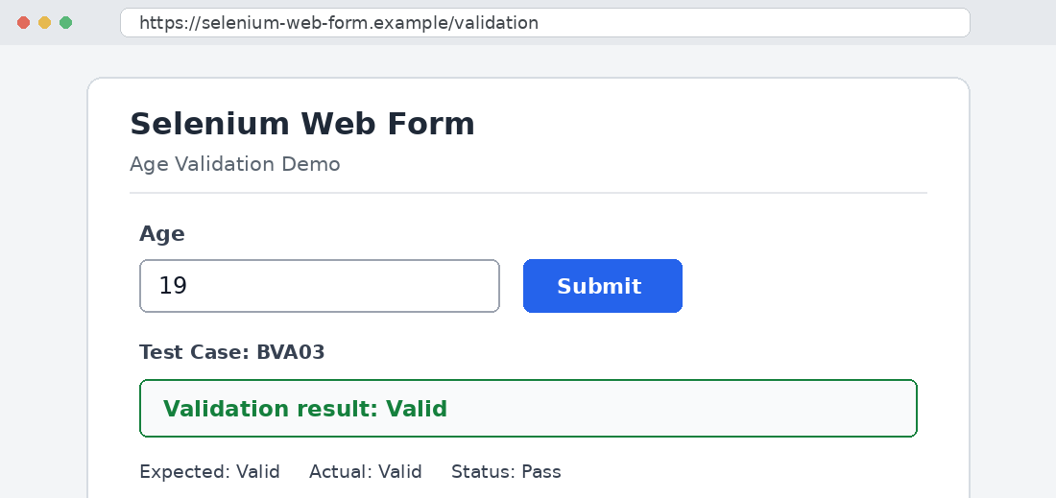

BVA04 – Input Age: 59
Execution: Enter age value “59” in the Age field and submit the form.
Expected Result: Valid
Actual Result: Valid
Pass/Fail: Pass
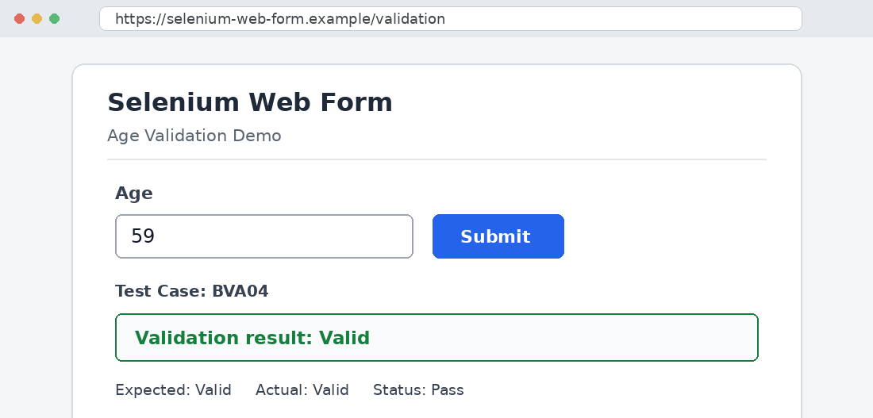

BVA05 – Input Age: 60
Execution: Enter age value “60” in the Age field and submit the form.
Expected Result: Valid
Actual Result: Valid
Pass/Fail: Pass
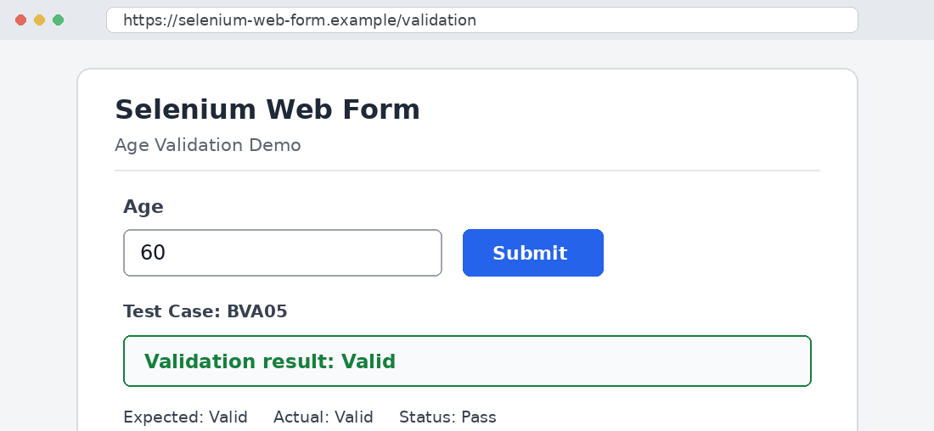

BVA06 – Input Age: 61
Execution: Enter age value “61” in the Age field and submit the form.
Expected Result: Invalid
Actual Result: Invalid
Pass/Fail: Pass
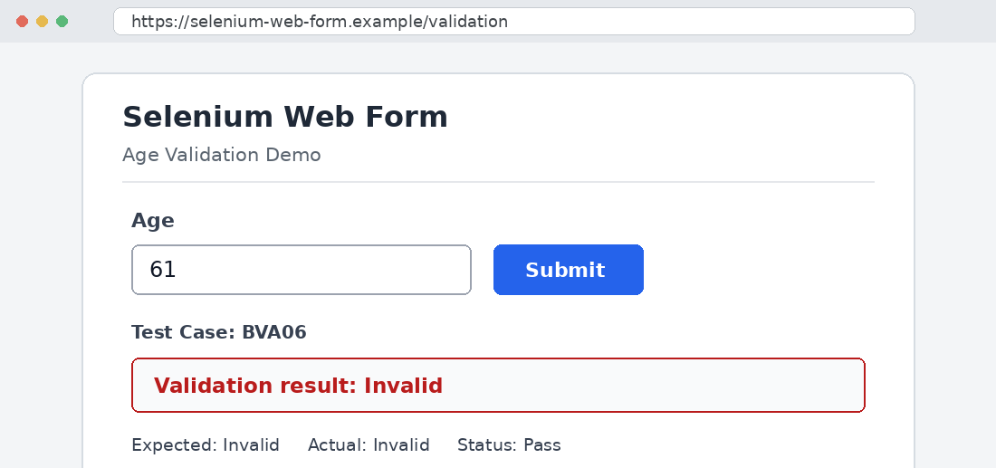

BVA Summary
Input | Expected Result | Actual Result | Pass/Fail
17 | Invalid | Invalid | Pass
18 | Valid | Valid | Pass
19 | Valid | Valid | Pass
59 | Valid | Valid | Pass
60 | Valid | Valid | Pass
61 | Invalid | Invalid | Pass

2. Equivalence Partitioning (EP)
Equivalence Partitioning divides the input domain into classes expected to behave similarly. One representative value is tested from each class.

Equivalence Classes
Equivalence Class | Range | Validity
EP01 | Below 18 | Invalid
EP02 | 18–60 | Valid
EP03 | Above 60 | Invalid

EP Test Cases
Test Case ID | Input (Age) | Equivalence Class | Expected Result
EP_TC01 | 15 | EP01 (Below 18) | Invalid
EP_TC02 | 30 | EP02 (18–60) | Valid
EP_TC03 | 65 | EP03 (Above 60) | Invalid

EP_TC01 – Input Age: 15
Equivalence Class: EP01 (Below 18)
Execution: Enter age value “15” in the Age field and submit the form.
Expected Result: Invalid
Actual Result: Invalid
Pass/Fail: Pass
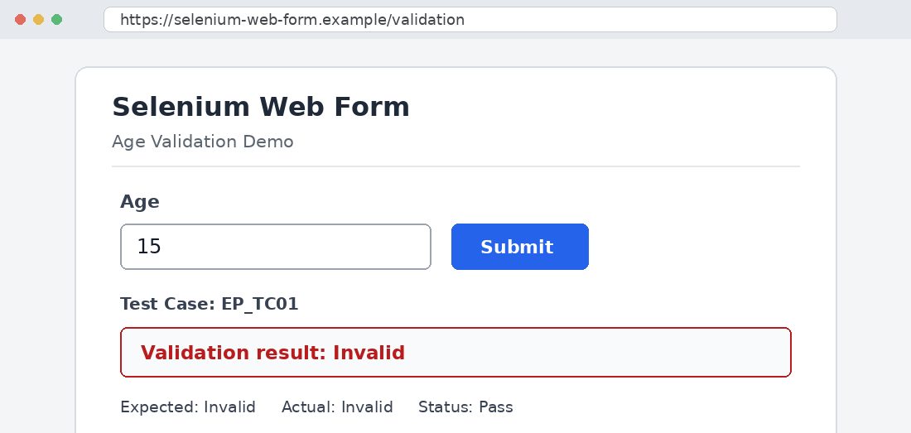

EP_TC02 – Input Age: 30
Equivalence Class: EP02 (18–60)
Execution: Enter age value “30” in the Age field and submit the form.
Expected Result: Valid
Actual Result: Valid
Pass/Fail: Pass
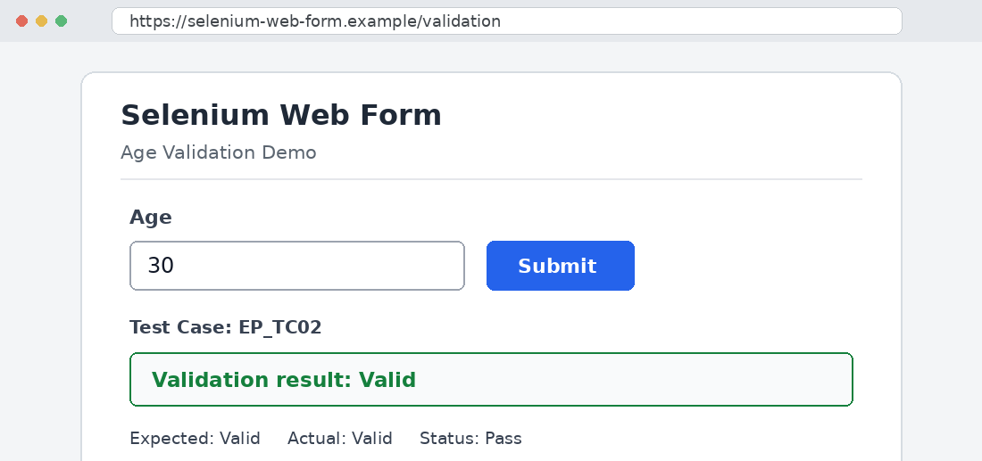

EP_TC03 – Input Age: 65
Equivalence Class: EP03 (Above 60)
Execution: Enter age value “65” in the Age field and submit the form.
Expected Result: Invalid
Actual Result: Invalid
Pass/Fail: Pass
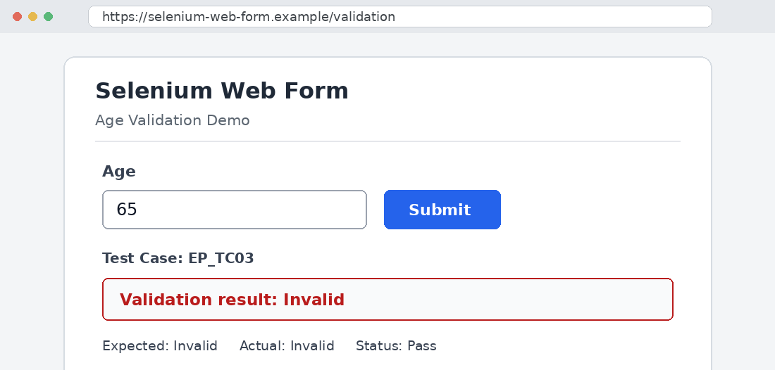

3. Test Execution Summary
For each test case, the age value was entered into the Age field and the form was submitted. The actual result was compared with the expected result.
Test Case ID | Input | Expected | Actual | Pass/Fail
BVA01 | 17 | Invalid | Invalid | Pass
BVA02 | 18 | Valid | Valid | Pass
BVA03 | 19 | Valid | Valid | Pass
BVA04 | 59 | Valid | Valid | Pass
BVA05 | 60 | Valid | Valid | Pass
BVA06 | 61 | Invalid | Invalid | Pass
EP_TC01 | 15 | Invalid | Invalid | Pass
EP_TC02 | 30 | Valid | Valid | Pass
EP_TC03 | 65 | Invalid | Invalid | Pass

4. Overall Test Summary
Parameter | Result
Total Test Cases | 9 (6 BVA + 3 EP)
Passed | 9
Failed | 0
Pass Percentage | 100%

Observation
- Six BVA test cases covered the boundary values around 18 and 60.
- Three EP test cases represented the invalid-below, valid, and invalid-above equivalence classes.
- All recorded actual results matched the expected results.

5. Conclusion
Boundary Value Analysis and Equivalence Partitioning were applied to test the Age field on a Selenium Web Form. All six boundary values (17, 18, 19, 59, 60, 61) and three equivalence-class values (15, 30, 65) matched their expected validation behaviour. The test report records 9 passed cases, 0 failed cases, and a 100% pass rate.

Signature with Date of Completion: ______________________________
Marks Obtained: __________ / 10

